Reg. No. CODE: SPH2
PH. D COURSEWORK EXAMINATION, MAY 2023
SUBJECT: MANAGEMENT
SPECIALIZATION PAPER II - SUPPLY CHAIN FINANCE
Time: 03 hours Maximum Marks: 50
Scholar Name: Mr. Samson Arun Prem Kumar Rathna

Instructions:
- Section A Compulsory
- Answer any four from Section B
- Each question carries 10 Marks
SECTION A

Answer the following question: (10 Marks)

- With the times, the finance industry is constantly changing. Blockchain technology continues to play an important role in supply chain finance. The security of the financial industry is very important. Blockchain technology can better protect the security of the financial industry, but there are also some risks like compromise of open source code, duplicate code signing, hijack of updates to software etc.
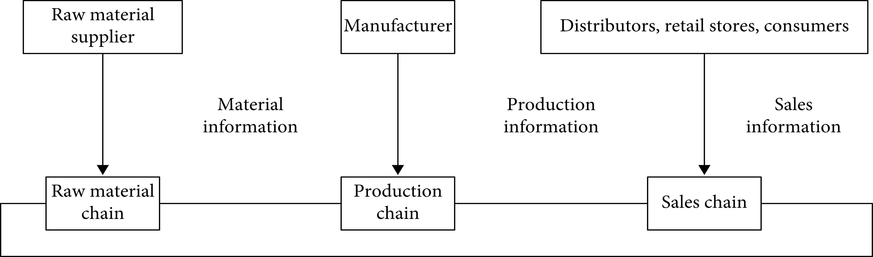
Block chain applied to Supply chain
Source: https://www.hindawi.com/journals/js/2022/1985803/
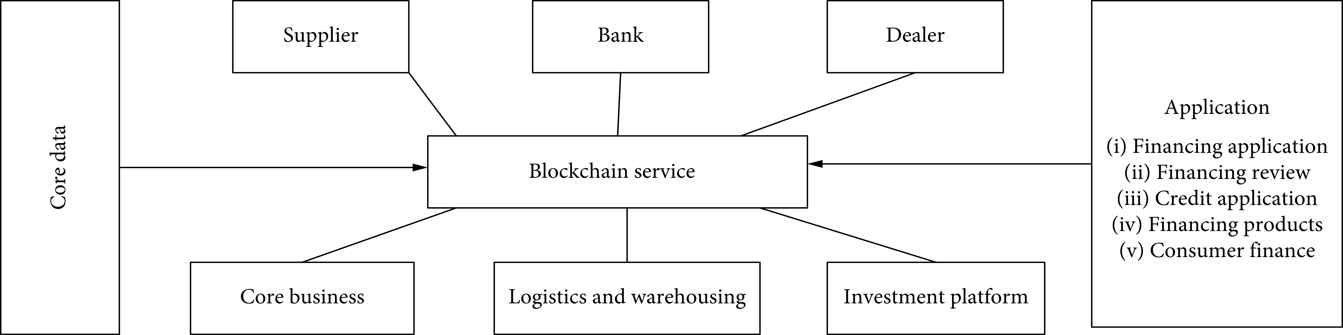
Supply chain financial performance services.
Source: https://www.hindawi.com/journals/js/2022/1985803/
Suggest measures that help mitigate risk in supply chain finance system by a firm.
SECTION B

Answer any four from the following question: (Each carrying 10 Marks)
- “Receivables management help SMEs in mobilizing short term finance at high cost of capital, making it to be one of easy and dynamic means of short-term finance” throw light on this. Use appropriate real time example to explain.

a. “NBFCs are major beneficiaries and supporters of supply chain finance in the money market” do you agree? Give reasons (5 Marks)

b. “Block chain technology is widely adopted in supply chain financial management” Do you feel that the present privacy and security norms are sufficient to tackle this? (5 Marks)

- Centralized cash pooling is a disastrous method of cash management in short term financial management” analyze the solution that can be shown by supply chain finance for this problem by comparing with cash concentration

- “Support vector machine method helps measure credit risk in commercial banks” Evaluate SVM merits to small and medium enterprises that deal in bulk cash transactions.

- “In India, supply chain finance is emerging short term money supply channel, which is still emerging and is uncertain of its sustainability”. Analyze the need and importance of sustainable supply chain finance along with suggested measures

- “Reverse factoring is a tool to measure the receivables health of a firm there by working capital, liquidity conditions” do you agree? Counter the statement with the help of real time examples.

********

